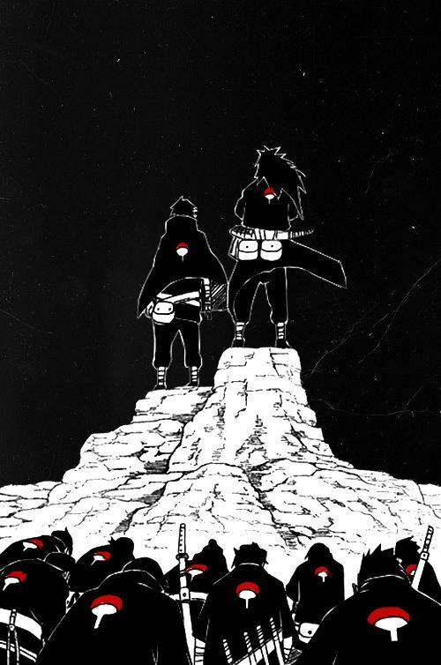  
  
Uchiha Clan  
  
  
The Uchiha Clan (うちは一族, *Uchiha Ichizoku*) is one of the three clans that reside in Watashitachi, wa Tsuiho. Reputed to be the houses strongest because of their Sharingan and natural battle prowess. They are marked for death by the Don’Yoku and of the three clans have the highest bounty placed upon their head. There is a wide spread propaganda about the Uchiha being spread that denounces their powers are from the devil itself. These various happenings cause the Uchiha to be infamous where ever they go.  
  
  
  
  
  
  
History  
  
**Preface**  
The Uchiha Clan are said to be born of the Purgatory Flames, the flames that first created life and then men. The Uchiha are said to be born of Asahi of The First Flame, A man who walked out of the Purgatory Flames and saved men from the Age Of Darkness. Due to this great belief the Uchiha held themselves to extremely high standards, and even after the Senju Clan had failed they decided to wage war with the Don’Yoku who had newly settled in their home. The Don’Yoku feared the Uchiha as the more the killed the stronger other got, fearing that they would be the only force able to stop them they soon spread propaganda about the Uchiha so wicked that other clan’s history began to die out in favor of the propaganda and payment. The Uchiha had been slowly subjugated by the Don’Yoku and marked for death with a large bounty upon their heads. The Uchiha clan’s power and fame were gone and replaced by words such as demon and devil, people believing them to be spawns of the devil themselves, and some wanting to claim the bounty. Soon Uchiha had rarely been seen in the land, although the Don’Yoku did not pull back- the increased the bounty once more which encouraged people to hunt them down. The Uchiha had to go into hiding, joining forces with the Hoshigaki and Kaguya to found Watashitachi, wa Tsuiho.

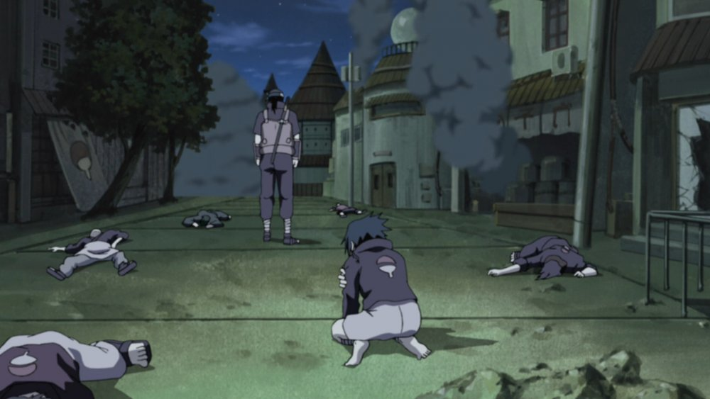

***The Uchiha being hunted for the Don’Yoku*  
  
  
  
  
Current**

The Uchiha reside over Watashitachi, wa Tsuiho as the leaders and are highly respected by the two other clans under them.Their current motives, location, and size are unknown by others as they’ve gone into a great hiding. However, with the new law that non-clans are allowed to join Houses they have opened their home to those who would like to join. Many believed that this clan had been exterminated and that overall hunting of them has died down as they are harder to be found, however the Don’Yoku have only raised their bounties as less and less Uchiha began to appear. Finding an Uchiha is an extremely rare occurrence and most people will not hesitate to take them and bring them from the massive reward.

Description

Uchiha are known to have strikingly black hair along with black eyes, where most we commonly be a dark shade of brown. They are known for their potent Katon Techniques and their Sharingan Kekki Genki.

Uchiha tend to be more noble and proud people, although they are quick to anger when they are belittled. They show intense emotions most of the time, that begin an intense hate for those they call their enemy and an intense love for those they call their friends.

Player Guide

*Uchiha are extremely secretive in nature as this is the way they are raised; they very rarely attempt to have the spotlight on themselves and would rather choose to move in darkness. They are not quick to trusting at all, even those who have shown no signs worthy of distrust. Their natural battle prowess makes them very confident when in battle. They sometimes have outbursts of anger or passion when something they truly care about in happening, or when they are with someone they really love. They tend to experience emotions much quicker then most, and can love or hate people with little to go off of them.*

* Those who play this character should be extremely careful, as the bounty on their head is an extremely high one and is a very hefty reward for anyone

- Uchiha can only have black hair and black eyes

**-**  Uchiha wear heavily concealing clothing making it harder to intensify them, and are raised to be quite secretive.

- They experience very intense emotions, even at the worst of times and feel as if they MUST act upon them

- Uchiha are known to especially feel emotional towards family, often lashing out at them when they feel belittled or take things the wrong way, or being over protective of them.

- Uchiha have a highly advance education, knowing all the basics as well as things like economics, social skills, and basic etiquette as well as other things.  
  
-Uchiha’s diet is well rounded consisting of various foods. Fruit, vegetable, meat, wheat, although they are known to be notoriously picky eaters.

-The Uchiha are quite proud of their battle skills and would rather flaunt their prowess then finish an enemy off quickly, sometimes this being their downfall.

-Uchiha often pray and ask from blessing from the Purgatory Flame. Phases such as “May the Purgatory Flame light my way.” Are often spoken by them

-The Mangekyo Sharingan has never been obtained through history, only word of mouth and stories have been said. Making this more of a myth within the clan but no knowledge is spread outside of the clan about it. Even the Uchiha have no idea what exactly it could do or how to obtain it.

- The Uchiha do not have a rivalry with the Senju, but have an intense hatred for the Don’Yoku and all who work for them.